**Nemertea a** unique **clade**

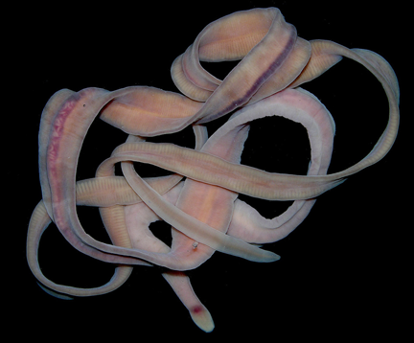

We have *Lineus sp.* , a very small nemertean that is found off our coast. No worm beats the Nemertean for surprising changes in length. Place a specimen in a small dish of seawater and place the container under the stereomicroscope. Try not to handle the specimens, use gloves and use small little round dishes to trap and transfer animals into larger containers. So not pick up with forceps, you will break the animal into pieces.

Watch the animal move. You may want to prove a small rock or shell that the specimen can hide under if it doesn’t settle down. Place the rock or shell at one end of the dish or simply wait for the specimen to choose a spot to settle down. Add a bit of liver or live worms. **Obtain a video of movement and the feeding (if possible) of the nemertean.**